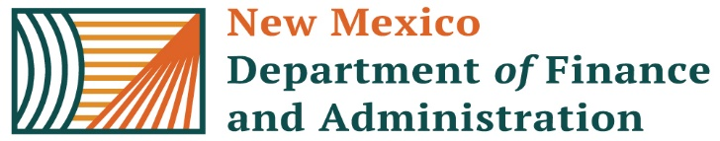
DIRECT DEPOSIT AUTHORIZATION FORM
EMPLOYEE INFORMATION

EMPLOYEE NAME:Click or tap here to enter text. Employee ID#:Click or tap here to enter text.

DIRECT DEPOSIT ENROLLMENT OR CHANGE AUTHORIZATION AND AGREEMENT

Type of action (select one): ☐New Enrollment ☐Account Change

Financial institution and account information:

Financial Institution Name & Address | Type  Checking = C Savings = S | Routing Number  (from your financial institution) | Account Number  (employees may have only one direct deposit account)
Click or tap here to enter text. | Click or tap here to enter text. | Click or tap here to enter text. | Click or tap here to enter text.
Proof of ownership: For the single account that you own, in whole or in part, and to which you want 100% of your net salary and wages directly deposited, please attach one of the following forms of documentation. For a checking or savings account, you may attach the first page of the most recent bank statement for the account showing your name on the account and the account number, with all financial information (e.g., balances and transactions) redacted. Alternatively, for a checking account, you may attach a voided, preprinted check listing you as an account owner.
Authorization and agreement:
I authorize the State of New Mexico (State) to directly deposit my net salary and wages to the account designated above and my financial institution to accept such deposits and credit them to this account. I understand and agree that:
- 100% of my net salary and wages will be electronically transferred to my financial institution and credited to the account designated above on paydays designated by the State;
- this direct deposit authorization and agreement supersedes and replaces any prior direct deposit authorizations and agreements, which I hereby revoke, and will continue in effect until I designate another account or I or the State cancel my enrollment in direct deposit;
- if the State is notified that the account designated above has been closed, I will receive payroll warrants until I designate a new direct deposit account;
- the State may, without liability to me, cancel my enrollment in direct deposit at any time, either temporarily for one or more pay periods or permanently, in which event I shall receive payroll warrants for the affected pay periods;
- in the event that my financial institution does not accept the direct deposit of my net salary and wages for any reason, the State has no obligation to process a supplemental salary and wage payment until my financial institution returns the non-accepted payment to the State; and
- I can cancel my enrollment in direct deposit or change my direct deposit account at any time. I understand and agree that it may take some time for the cancellation or change to take effect, during which time my net salary and wages will continue to be directly deposited in the account designated above.
In the event that more money is deposited into my account than is due to me, I authorize the State to deduct from the account designated above all amounts deposited to the account in error and authorize my financial institution to allow such deductions and return the erroneously paid amounts to the State.

Employee Signature: ______________________________________ Date:Click or tap to enter a date.

Revised 04/30/2025

